Ysgol Coedcae School

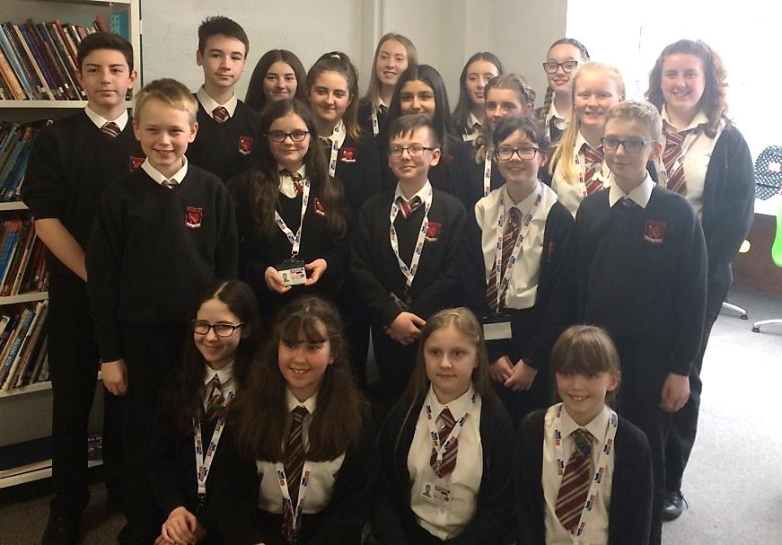
Pupils at Ysgol Coedcae School took part in the BBC School News Report Day on Thursday 15th March 2018.

They spent the day as journalists where they researched news stories, wrote scripts, filmed and edited podcasts, and wrote their stories into articles.

This magazine has been compiled to showcase the work they accomplished throughout the day.

Here are the pupils who took park in the BBC School News Report Day:

Finley
Rebekah
Faith
Ayisha
Bella
Hannah
Ryan
Eliza
Natalia
Joseph
Celyn
Rhys
Ela
Daisy
Evie
Scarlet
Seren
Mason
Maddie
Jessica

Domestic Abuse- Killing or Harming?

By Jessica, Faith, Bella and Natalia

There is a huge problem concerning everyone - young and old. In the U.K there is a high rate of domestic abuse. It harms the victim, leaves them emotionally scarred and gives them low self-esteem. Here we have some facts about domestic abuse:

In 2011/12 the police reported nearly 800,000 incidents of domestic abuse

31% of women have experienced domestic violence since the age of 16

On average, 2 women are killed EVERY WEEK by their partner or former partner 10% of emergency calls are related to domestic violence.

On average the police receive over 100 calls of domestic abuse EVERY HOUR

Domestic abuse will increase its statistics if you don’t help prevent abuse in the future. In an interview with the head boy and girl of Coedcae school, head boy said “domestic abuse is a problem because it leaves the victim emotionally hurt.” Also the head girl said “We as a school can help by supporting the white ribbon and raising awareness about the campaign.

Another person interviewed was miss Roe, the head of R.S.T in Coedcae. She said “People who are domestically abused will feel relieved when it is over but mentally they will be unstable.”

Brits, Oscars and the UK Top Charts

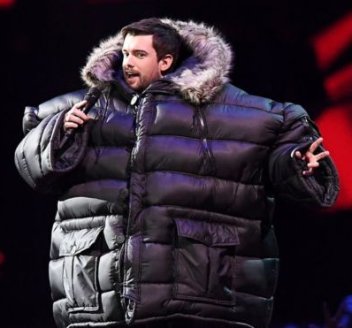
By Scarlet and Hannah

This year’s Brit awards were hosted by Jack Whitehall. Global success award was won by Ed Sheeran. The British video was won by Harry Styles’ song ‘Sign of the times.’ The British female solo artist was won by Dua Lipa who has only recently become popular in big music industrys. And to finish off with the brits section that we did was British single which was won by Rag ‘n’ Bone man’s song Human.

We decided to look at four awards that we found the most interesting. The first award we found interest in was best sound editing which was won by the film ‘Dunkirk.’ The second award is best production design won by the new release ‘The shape of water’ which isn’t even in certain cinemas yet. The best actor award was won by Gary Oldman, with his starring role in ‘Darkest hour’. The last award we found interesting was best costume design which was won by Phantom Thread.

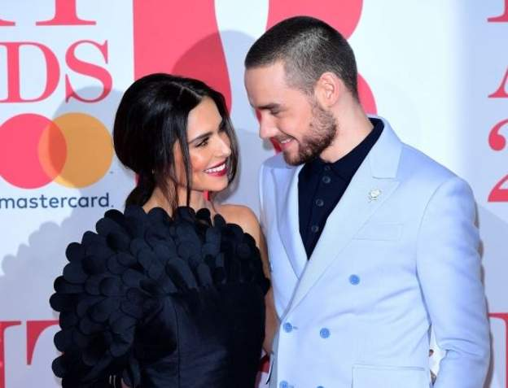
Number 10 in the charts Liam Payne and Rita Ora’s song ‘For you’ which was featured in the film ‘Fifty shades freed’. Number 9 is ‘Say something’ sung by Justin Timberlake. ‘All the stars’by Kendrick Lamar is number 8. Number 7 is ‘This is me’ from the newest musical the greatest showman. ‘Physco’sung by Post Malone is number 6. Marshmello & Anne-Marie’s single ‘Friends’ is at number 5. The single ‘Feel it still’ by Portugal The Man is number 4. Dua Lipa’s most recent song ‘IDGAF’ is number 3. Number 2 in the charts is Rudimental’s song ‘These Days’. And finally, number 1 in the charts is one of Drake’s most recent songs titled ‘Gods Plan’ and has been number 1 for 7 whole weeks!
Goodbye Sir Bruce Forsyth
By Ayisha and Evie
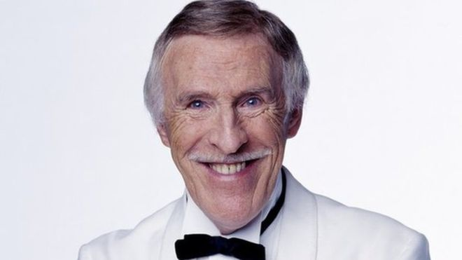
Bruce Forsyth was a British presenter who is most known for Strictly, The Generation Game and play your cards right. He was first spotted by the British public in the 1950’s and he holds the Guinness World Record for the longest male TV career. Bruce has won many awards in his lifetime. He won the lifetime achievement award in 1995, he then won a BAFTA for the academy fellowship in 2008, and finally he won an NTA for the special recognition award. For seven and a half decades of TV, Bruce has produced some of the most memorable catchphrases many will not forget. Some of which were “nice to see you…to see you nice” and for all of the Strictly Come Dancing lovers “Keep dancing” will always be a memorable one.

His death shocked the nation. However, this has encouraged people to share the memories they had with Bruce. Especially his third wife who opened up about how she met Bruce. They met in 1980 while they were both judging the miss world competition in Paris .As soon as she saw him making all the contestants very at ease, she knew he was wonderful.

Jessica kindly joined us, she is a fellow Strictly Come Dancing lover and she answered a few questions for us.

How did you react when you found out and how did it make you feel?:
“When I found out that Bruce passed, I was heartbroken. He is a crucial member of the entertainment community and will be remembered in my heart forever”.

How do you think if affected the county?
“The country was heartbroken, we were all devastated that that this legend had died.”

Lastly, what was your favourite memory of Bruce?
“I enjoyed all of his little quirks throughout his time on strictly.”

Many tributes were paid to Bruce after his passing .BBC director Tony Hall paid tribute to who he described as one of the greatest entertainers ever known. His statement read “Sir Bruce was one of the greatest entertainers our country has ever seen, he delighted millions of people and defined Saturday night television for decades.

On the 18th August, the world lost a national treasure that had an amazing chemistry with all of his audience and the British opened up their hearts to.

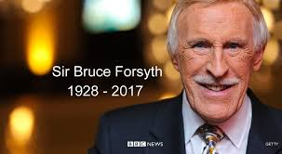

School Shootings and Gun Laws
By Maddie and Celyn

School Shooting in America that have happened and left many families and schools heart broken and traumatized. These incidents happen because of the gun laws in the U.S but also because of the people who have commit these awful acts.

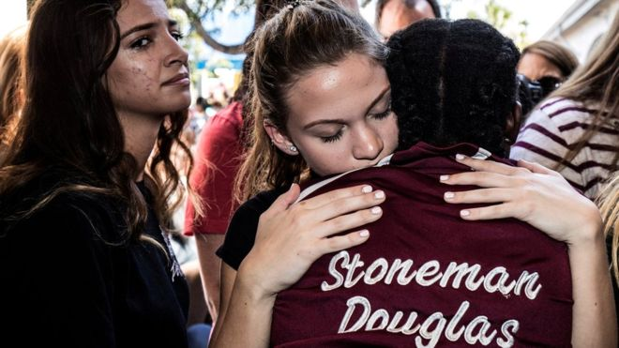
Parkland shooting
On February 14th 2018 a mass school shooting occurred in Stoneman Douglas High School in Parkland Florida. 17 people were killed and 17 more were wounded all by bullets. When the students went back to the school after its closing many of the students had confronted state and federal law makers demanding a ban on weapons similar to the guns used to kill their friends and teachers. Students across the country continued to fight for gun reform by walking out of class man of them for at least 17 minutes: one for each person killed in parkland. Students are now turning their attention to March 24th when gun control activists will participate in the march for our lives in Washington. The event was created by Stoneman Douglas students.
Gun Laws in the U.S and U.K
US gun law
-Florida Governor Rick Scott broke with the National Rifle Association and signed a major gun safety bill into law. With this the Marjory Douglas high school managed to persuade the governor to rise the age of purchasing a gun from 18-21 and create a 3 day period for most firearm purchases.

UK gun law
-First of all, section 5 fire arms like hand guns are banned unless you are a police officer or army personnel. You can purchase a gun/ firearm if you are over 18 and you have to apply for a license. If you are otherwise caught handling or carrying a firearm and you do not have a license it would get taken off you and a reasonable explanation would need to be told to the officer. Military grade weapons like machine guns and automatic rifles are strictly forbidden but not for army personnel.

Sandy Hook massacre
The Sandy Hook elementary school shooting occurred on December 14th 2012 in Newtown, Connecticut. 20 children between the ages of 6-7 years old were killed including 6 adult staff members. The shooting prompted renewed debate about gun control in the US and for new federal and gun legalisation banning the sale and manufacture of certain types of semi-automatic firearms and magazines with more than 10 rounds of ammunition.

Columbine Shooting
-Columbine High School in Littleton, Colorado, two teens went on a shooting spree on April 20th 1999 killing 13 people and injuring more than 20 others before turning their guns on themselves and committing suicide. At the time, the massacre was the worst high school shooting in US history. A national debate on gun control and school safety in addition to the shootings the complex and the highly
We thought of a Scenario and asked our deputy head and safe guarding officer Mrs Allen
“If all guns were legal in the UK and an intruder walking into our school with a possible firearm on them, what would be our plan / policy?”

-Mrs Allen, our deputy head and safeguarding officer answered this: “Site security is maximised to ensure all pupils are safe, all protocols for unforeseen events are in place with all staff trained and updated regularly.”

planned attack involved a firebomb to divert fire-fighters, propane tanks converted to bombs placed in the cafeteria, 99 explosive devices and car bombs.

Dunblane shooting
There was one killing spree in Dunblane in June 2010 involving a shotgun and a .22 caliber rifle both legally held prior to Dunblane though there has only been one mass shooting carried out by a civilian in the entire history of Great Britain which took place in Hungerford on the 19th August 1987.
Earhart Mystery Solved?

By Eliza
Top scientists are 99% sure that they have found Amelia Earhart’s remains. The skeleton was found on the uninhabited island of Nikumoro, formerly known as Gardener Island. After 81 years of searching, scientists believe that the famous aviator has been found at last.

Amelia Earhart was the first woman to fly across the Atlantic Ocean when others had tried but they never succeeded. She was also the 16th woman to be granted a pilots license as she was inspired to become a pilot after witnessing an air show. She was born on 24th July 1897, and her nickname was Lady Lindy. She was married to publisher George Putnam. She had a younger sister named Muriel, and she spent a lot of time catching frogs with her as a child.

Earhart and her navigator Fred Noonan were attempting a round the world flight from Papa New Guinea to Howland Island. The pair were flying over the Pacific Ocean around 100 miles away from Howland Island, when they lost communication with HQ, and they were never seen again. There are several conspiracy theories floating around claiming that she was captured by Japanese forces, or she drowned at sea. Both theories are plausible if not morbid, but recent evidence shows that she might’ve crashed on Nikumoro Island and her and Fred lived a short life on that island.
Scientists claim that they have found Earhart’s remains on the desolate island of Nikumoro. They have measured her bones in different pictures so that they could get precise and accurate measurements. Upon further investigation of the island, scientists found a pot of freckle cream and clothing fibre. Considering the fact that the island is uninhabited, and Amelia had quite a few freckles so it is almost certain that the bones and cream belonged to them. After 81 years spent searching and $4 million dollars spent on finding her, it has finally paid off. It is quite likely that they either starved to death, became dehydrated or died of exposure to harsh conditions.

Stephen Hawking
By Finley
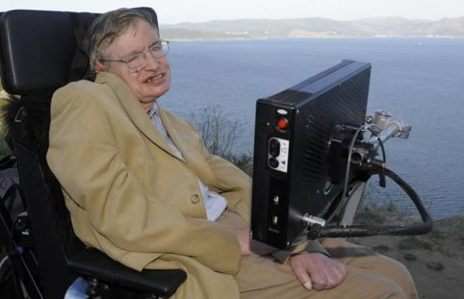
Stephan Hawking is well known physicist/scientist who surprised the world (only supposed to be living up to) 20-30’S by living up to 70 decades and a half. As he lived on he become one of the greatest mind and his incredible theory’s

The man had a IQ like Albert Einstein the IQ test this was a very high score since the highest score ever achieved 162 this is genies level so you would not be surprise if Stephen had many awards. In fact Mr Hawking has won over15 medals awards such as the Einstein award presidential medal of freedom and many others and all the way through he has been in a wheelchair this is a quote from him that makes this true ‘even through you have disability holding you back you can do ant

Mr Hawking lived truly grand life with friend’s awards and the greatest trophy of all a family, he was even honoured to be the inspiration person of the movie the theory of everything were the protagonist is Stephan and it is following him through his younger life.

Fake News
By Ela and Rhys

Social media is supposed to engage more people in politics. However, although people’s feeds are full of current affairs and political issues; but not all these stories are true or completely accurate. Joseph Goebbels ; head of Adolf Hitler’s propaganda once said ‘If you tell a lie big enough and keep repeating it, people will eventually come to believe it’ That quote you just read is completely and utterly FAKE he never said that. We have always had fake or incorrectly reported news but since the invention of social media the percentage of fake news has risen dramatically. Fake news can be a hoax for fun, to mislead or try to gain political or financial rewards. For example ‘Donald Trump believes in ghosts’. Just because posts like these may gain millions of comments and likes it does not mean that it is pure truth. Many people who have not been correctly informed about fake news may believe however that it is true. It is essential to understand the truth and possible dangers of fake news as well as to be able to identify it. A good way to know if the news is fake is to check the accuracy of the source; if the source proves inaccurate then it is fake. Another solution would be to check if it’s on mainstream or media news, or you could look on snopes which is a site that challenges and attempts to confirm whether fake news is true or not. People may fall for fake news due to a variety of reasons such as they may want to believe it; it might support their views or make them angry. If we are supposed to become engaged in politics then we need to check whether what we are seeing is true. People all around the world; anyone with a phone a computer or a tablet can access these forms of social media this means that they are able to see or post incorrect information. Unfortunately this means millions of people are polluted with this news, much quicker than before the creation of social media.

Tips for recognising fake news
- Check if the webpage is a co.uk or .com if is then it may be more likely to be true. But this is not always correct
- Does the story sound fake or made up
- Is the story only displayed one page. If it is displayed on many sites it is more likely to be a true story
- Is the page secure. If a lock is displayed in the URL box it is probably a genuine site.
Cancer Research
By Bella

There is only 42% out of 100% preventable cases of cancer in the UK. There are 359,960 cases of cancer in the UK as of 2015.Think of how much your money can help cancer research, or what your participation in sponsored cancer runs, walks, cake sales, sponsored cancer silences and many more can help cancer research. Cancer is something that ruins lives, we need to help the community and save people who need our help and support.

April Coslett said “my bampa died from pancreas cancer, and as a community we all know about sponsored cancer walks, runs and cake sales, but we could include unique activities to increase the fundraising activities”. Another person who we have interviewed is Kimberley Lewis and she said “I think that it is a good idea to do sponsored cancer runs and walks, I think we could also do sponsored cancer cake sales and sponsored cancer silences.” Kimberley also said “yes I think that over the past few years, the cancer treatments has effectively changed and has become more successful.”

Risks of Technological Advancement
By Joseph

Technology is evolving, that’s for sure. Self- driving cars drones and even vr is around now. But these gadgets have high risks, not like in the movies! One wire wrong in that self-driving car can kill you, one wrong move and your drone can take a plane down. A few wrong steps and you won’t want or need to leave the house again. Extroverts are going extinct so come on! Go out to play in the summer sun, it only comes once a year. Post mates, uber eat, online shopping and more reduce the actual need to go out of your house. You can even see whatever you want for the price of a vr which of course you don’t need to leave your house to pick up one of those either

Drones are already starting to get banned, they invade privacy! Drones are also very dangerous, and not many people know of this. Drones can take down helicopters and planes! So if you’re flying a drone be careful. If you do own a drone make sure that you check the drone laws and if needed get a drone licence so that you are not breaking the law
VR is a very cool device that lets you see a simulated world 360 degrees around you. However not having to leave your house with not just this but other apps is very bad for your health, you are being anti-social and are being blasted with constant light which can be extremely damaging for your eyes just like phones, tablets TV’s and lots more devices

Self-driving cars are the vision of the future and nearly always have been. Now they’re coming to us we need to realise the risks. When in that car your life relies on everything to be perfect. It relies on you still looking at the road anyways, however people probably won’t, leading to incidents and accidents. As evolution of technology goes on the car companies will probably be confident to face the front chairs to the back chairs however even when that happens you must look out for any chance a car could hit you!

talked about how VR is terrible for a human as it makes the illusion on the mind that they can just go on there and not leave the house, however phones can be even worse! Post mates, online shopping and even more apps/ internet pages can make it not needed to leave your house

Obesity, Anxiety and Depression
By Rebekah

Hello, my name is Rebekah, and today I will be talking about obesity and the effect of it. Obesity can cause all types of things, not only health issues but mental health issues like depression and anxiety. These things should never go a miss and they are getting a bigger problem every single day, BBC news reports even said, as I quote ‘Obesity quadruples to nearly 1 billion in developing world.’ If you continue to listen you might just find out more.
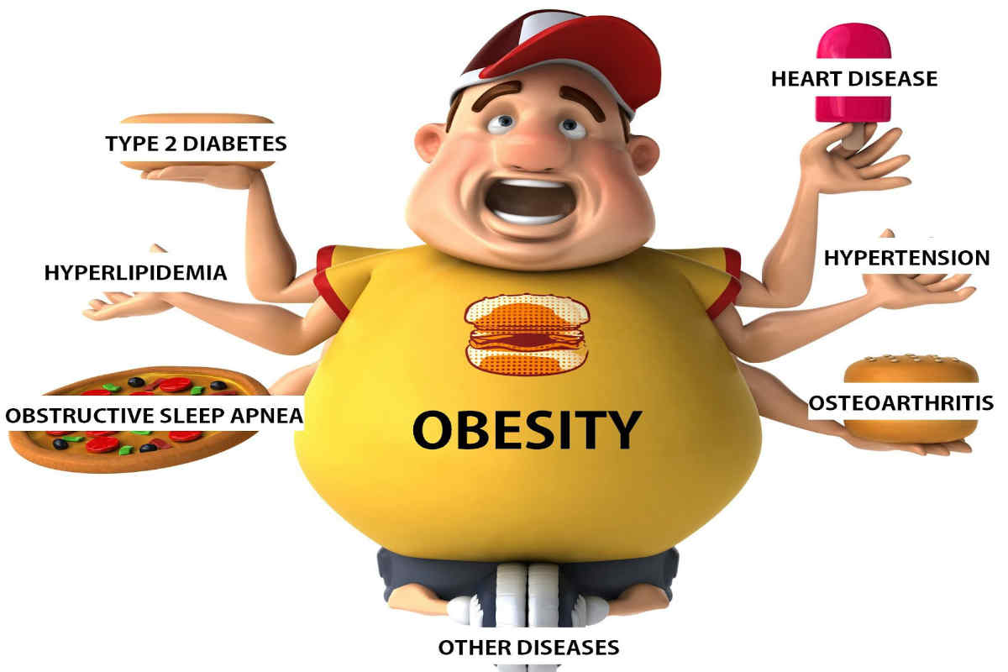

Firstly, did you know? 1 in 5 children in RECPTION are overweight? This includes boys being 22.6% and girls being 21.2%, I know this is crazy but it’s true. Also 1 in 3 children in YEAR 6 are overweight? This includes boys being 34.9% and girls being 3`.5%. The point of this presentation isn’t to make you look bad or to feel under pressure but for this to be an eye opener for all. Obesity is becoming a bigger problem and it needs to be addressed, and as we can see to ALL age groups.

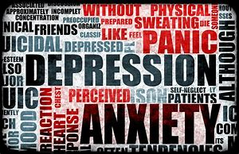
Now also a huge problem, anxiety and depression. Now anxiety is HUGE! There has been a rise of 35% of the calls that Childline receive about anxiety. Childline quoted ‘People receive anxiety from the age of 8! Also girls are 7 times more likely to contact Childline than boys.’ This is crazy and really heart breaking. This traumatic news shocked me, I don’t know about you but I couldn’t believe that this is the type of world we live in. In the UK they also have revealed that women are twice as likely to be diagnosed. I also reached that in London last year, they counselled 412 people with anxiety and / or depression. That’s almost 6,500 counselling sessions in 6 months.

I hope this makes you realise that the world we live around isn’t all that pretty, and no this isn’t because your over weight but it’s because the people who judge you for being overweight, thank you for listening goodbye!

